Nama : Ahmat baihaki

Nim : 17.52.0002

dataset <- read.csv ('C:/Users/Zul/Downloads/Tugas/Dataset_superstore_simple.csv')

select(dataset,order_id)

library(dplyr)

nomer1

datasetno1 <-dataset %>% select(customer_id,sales) %>% filter(sales==max(sales))

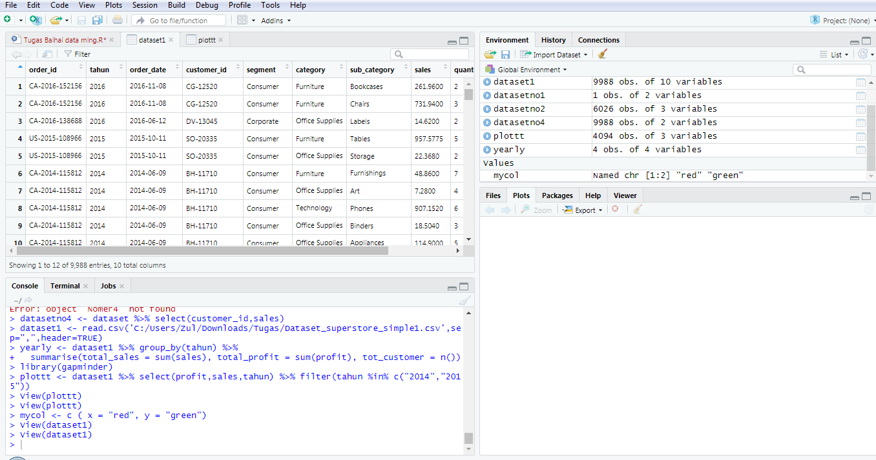

nomer2

datasetno2 <- dataset %>% select(category, sub_category,profit) %>% filter( category=='Office Supplies')

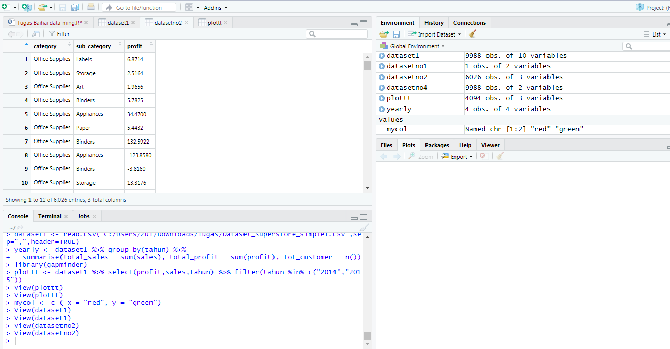

nomer3

datasetno3 <- dataset %>% select(order_id, profit) %>% filter( profit<0)

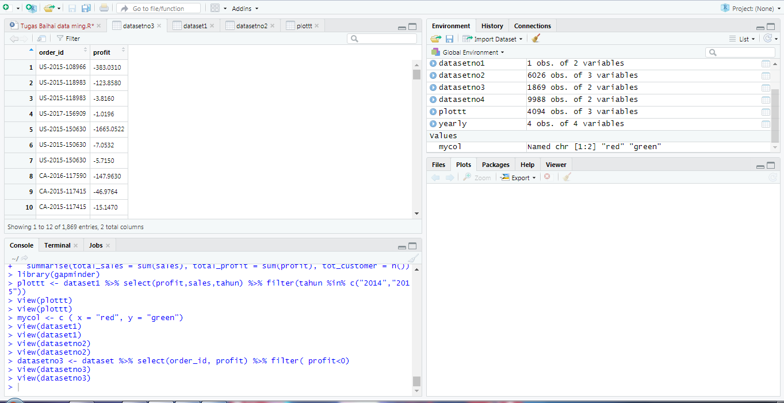

Nomer4

datasetno4 <- dataset %>% select(customer_id,sales)

dataset4.1 <- filter(datasetno4, customer_id=='JE-16165')

dataset4.2 <- filter(datasetno4, customer_id=='KH-16510')

dataset4.3 <- filter(datasetno4, customer_id=='AD-10180')

gabungan_data <- bind_rows(dataset4.1,dataset4.2,dataset4.3)

sales_terbanyak <- group_by(gabungan_data,customer_id)%>% summarise(total_sales = sum(sales))

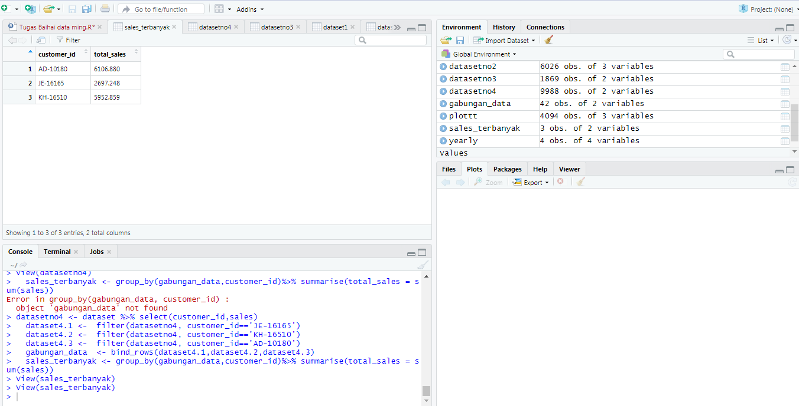

No5

dataset1 <- read.csv('C:/Users/Zul/Downloads/Tugas/Dataset_superstore_simple1.csv',sep=",",header=TRUE)

yearly <- dataset1 %>% group_by(tahun) %>%

summarise(total_sales = sum(sales), total_profit = sum(profit), tot_customer = n())

provitmax <- filter(yearly, total_profit == max(total_profit))

No6

library(gapminder)

library(ggplot2)

plottt <- dataset1 %>% select(profit,sales,tahun) %>% filter(tahun %in% c("2014","2015"))

attach(plottt)

mycol <- c ( x = "red", y = "green")

plot(sales~profit,

col = mycol[continent], main = "Sales Vs Profit 2014-2015",

xlab = "Sales", ylab="Profit", pch = 1,

frame = FALSE)

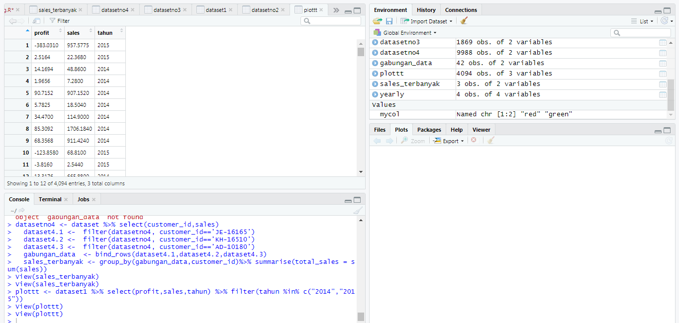

Maaf bu nomer 6 tidak bisa menmapilkan visualnya bu